15.1.1 Editors - Dope Sheet - Header tools and options
Introduction 3
Header Tabs 3
Dope Sheet Modes 3
Dope Sheet 3
Action Editor 3
Shape Key Editor 4
Grease Pencil 4
Mask 4
Cache File 4
All Modes - Filters 5
Summary 5
Only Show Selected 5
Show Hidden 5
Only Show Errors 5
Filtering Collection 5
Filter by Type 5
Options 6
Sort Data Blocks 6
Multi Word Match Search 6
All Modes - Proportional Editing 6
All Modes - Keyframe Handle Type, Keyframe Interpolation, Keyframe Type 6
Handle Type 6
Interpolation Mode 6
Keyframe Type 7
All Modes but Grease Pencil - Auto Snap 7
Action & Shape Key mode tools 7
Next Layer / Previous Layer 7
Push Down 7
Stash 7
Action Data Browser prop 8
Action Data Browser 8
Number of Fake Users 8
Fake User 8
New Action 8
Unlink Action 8
Grease Pencil mode tools 8
Add new Layer 8
Remove Layer 8
Layer Specials 8
Duplicate layer 8
Show All 8
Hide Others 9
Lock All 9
Unlock All 9
Autolock inactive Layers 9
Merge Down 9
Copy Layer to object 9
Move Grease Pencil Layer upwards 9
Move Grease Pencil Layer downwards 9
Isolate Layer with visibility 9
Isolate Layer without visibility 9

Introduction

The header contains various menus and tools. This chapter here is about the tools, modes and options elements in the header.

The text menus are covered in a own chapter each. They vary too much, dependant of mode and object type.

Header Tabs

The tabs at the very left allows you to switch between the four most important editor types by one click. Dopesheet Editor, Graph Editor, Driver Editor, NLA Editor.

Dope Sheet Modes
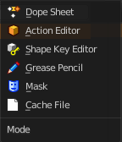
The Dopesheet has different modes. Each mode has its own purpose. In Mask mode you can for example see and edit the keyframes for mask animations, from the movie clip editor for example.

Dope Sheet
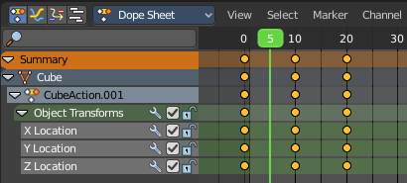
Display the keyframe animation of all currently selected object in the 3d view.

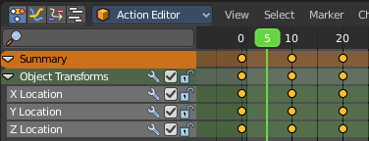
Action Editor
Display and edit the Action part of a keyframe animation of the currently active object in the 3d view. Just the data for this one object is displayed.
Actions are a generic containers for F-Curves. Actions can contain any number of F-Curves, and can be attached to any data block. For example, an action that modifies the ‘X location’ and ‘Y location’ properties can be shared across multiple objects, since both objects have ‘X location’ and ‘Y location’ properties available.
The Action editor allows you to edit the animation in various ways. For example also turn a keyframe animation into a clip for the NLA editor.
The animation data is build in an hierarchical way. From top to bottom.
Actions - Record and contain animation data.
Groups - Are groups of channels.
Channels - Contains record properties.
F-Curves - F-Curves are used to interpolate the difference between the keyframes.
Keyframes - Keyframes are used to set the values of properties bound to a point in time.

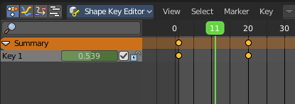
Shape Key Editor
Display and and edit the keyframes for shape key animations. Shapekeys is vertex animation.

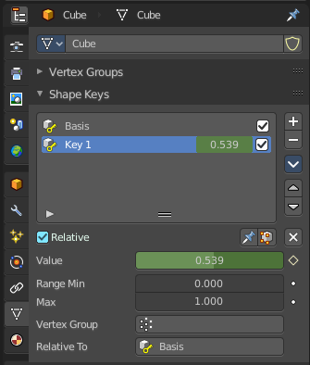

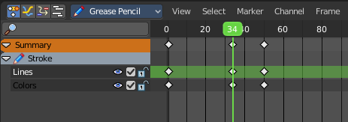
Grease Pencil
Display and and edit the keyframes for animated grease pencil strokes. This mode is for when you animate grease pencil strokes and colors at a vertex level. When you record keyframes at an object level then those keyframes gets displayed in the Dopesheet and Action mode.

Mask
Display and and edit the keyframes for animated mask curves. Like from the movie clip editor.

Cache File
NOT DOCUMENTED BY BLENDER. NOT TO FIND OUT HOW TO USE.
From the Blender Manual: Cache File: Alembic Todo 2.78.

All Modes - Filters
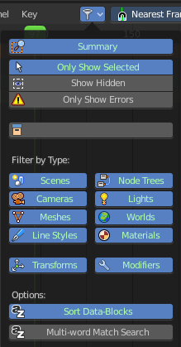
The Filters panel allows you to filter out elements.
Note that in other modes the panel does not show all content. In Action Editor mode for example it just shows the first four elements.

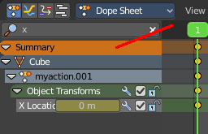
Summary
Display the Summary label above the list of elements.

Only Show Selected
Display only the data for the selected object in the list of elements. If off it displays all available animation data of the whole scene.

Show Hidden
Include channels from objects / bones that are not visible. This feature just works with Only Selected off.

Only Show Errors
Only display F-Curves and Drivers that have errors or are disabled.

Filtering Collection
Just display the content from the chosen collection in the list of elements.

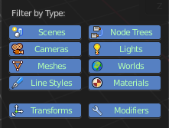
Filter by Type
In this section you can choose what type of animation data should be displayed. The names should be self explaining.

Options

Sort Data Blocks
Alphabetically sort the data in the list of elements.

Multi Word Match Search
Enable Multi Word matching for the search in the list of elements.

All Modes - Proportional Editing

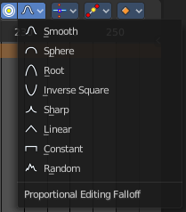
Enable proportional editing.

Proportional editing allows you for example to scale two keyframes and influence the not selected neighbour keyframes in a proportional way. Or the proportional editing of fcurve points.

The dropdown menu to choose the proportional editing falloff method is just available when the proportional tool is active.

All Modes - Keyframe Handle Type, Keyframe Interpolation, Keyframe Type

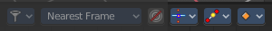

Handle Type
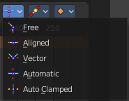
Set the handle type for the currently selected keyframes.
This is a feature for the Graph editor, where each curve point has its own handler with which you can influence the curve behaviour. But the handler type also influences how the animation curve acts at the chosen keyframes. So it has its use in the dopesheet editor too.
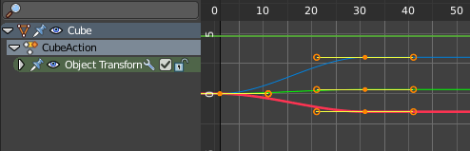

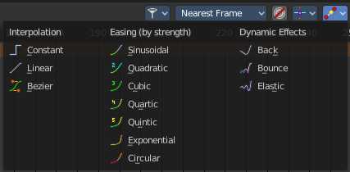
Interpolation Mode
The Interpolation mode defines how the curve acts from keyframe to keyframe. You can have a linear curve between two keyframes instead of a bent one for example.

The easing methods here in the interpolation mode menü are for the easing shape. There is also a easing menu where you can choose a easing method.

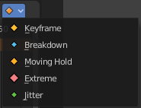
Keyframe Type
Recolor the currently selected keyframes. Or create the next keyframe with this chosen keyframe color.

All Modes but Grease Pencil - Auto Snap

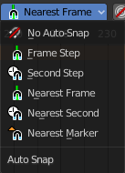
Adjust how the selected keyframe or fcurve point snaps to other elements.

Action & Shape Key mode tools

Next Layer / Previous Layer
When there is more than one animated object in the scene then you have most probably more than one action in the scene too. Switch to previous or next actions to use them in the current object.

Push Down
Adds the active action on to the NLA stack as a contributing strip. The same can be done by pressing the Push Down button in the NLA Editor.

Stash
Stashes the active action on to the NLA stack. This means it is added as a non-contributing stack in the same way that it would if you were creating a new action instead.
Note
Push down and Stash adds the action to the NLA stack. It is cleared / unassigned from the active action slot.

This means that the action cannot be edited anymore fom the Action or Graph Editors, unless you enter “Tweak Mode” on the corresponding strips later.

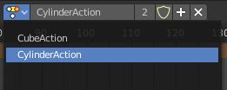
Action Data Browser prop
When there is more than one animated object in the scene then you have most probably more than one action in the scene too. The Action Data Browser allows you to display, select and rename the available actions in the scene.

Action Data Browser
The list of available actions in the scene.

Number of Fake Users
Displays the current number of fake users for the active action.

Fake User
Assign a fake user to this action. Fake users is a odd concept to keep data in the scene even if it has no user somewhere. The fake user is then a dummy user so that the object is not deleted when saving the scene.

New Action
Add a new blank action.

Unlink Action
Delete the current active action.

Grease Pencil mode tools
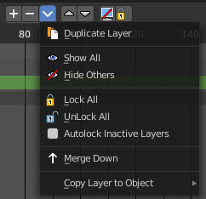

Add new Layer
Adds a new blank grease pencil layer.

Remove Layer
Removes the currently selected grease pencil layer.

Layer Specials
A menu with grease pencil functionality.

Duplicate layer
Duplicates the currently selected grease pencil layer.

Show All
Shows all hidden grease pencil layers.

Hide Others
Hides all grease pencil layers but the selected.

Lock All
Locks all grease pencil layers.

Unlock All
Unlocks all grease pencil layers.

Autolock inactive Layers
Lock automatically all layers except active one.

Merge Down
Merge the current layer with the layer below.

Copy Layer to object
Copies the grease pencil layer to another object.

Move Grease Pencil Layer upwards
Moves the grease pencil layer upwards in the hierarchy.

Move Grease Pencil Layer downwards
Moves the grease pencil layer downwards in the hierarchy.

Isolate Layer with visibility
Locks and hides the currently active grease pencil layer.

Isolate Layer without visibility
Locks the currently active grease pencil layer.

